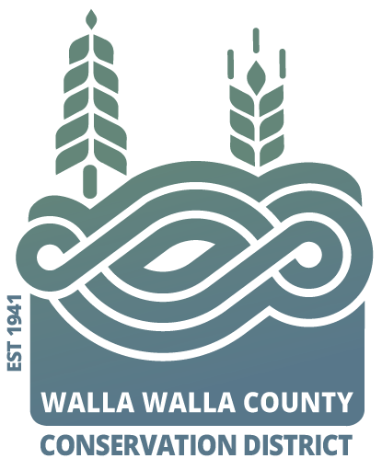
AGENDA
for the Walla Walla County Conservation District
Board of Supervisors Meeting
Monday January 8, 2024 at 4 p.m.
via Zoom & USDA Service Center conference room,
325 North 13th Avenue, Walla Walla WA

Call to Order..................................................................................Chair Kent

Welcome Visitors!
Request for Public Comments:

*Review and Approve Minutes of Dec Board Meeting
Review of Financial Report (per recent training, financials should not be approved)

NEW BUSINESS
- Partner updates (NRCS, WSU Extension, WDFW, WACD, and/or SCC) Hadley
- NRCS office lease quarterly update…………………………Cowles Cleveland
- WWCCD Annual Meeting review and election update…Hadley for Byerley/Garza
- *Request for pre-approval of meal and refreshments for WWCCD annual meeting
- Request for 2 board supervisors for Performance Committee to conduct annual employee reviews………………………………………………….Hadley
- Update on 2024 budget estimates…………………………………………Freer
PROGRAM UPDATES (as of Dec. 2022 employee reports will shift to a rotation of detailed presentations instead of high-level reports)
- Klundt: Agricultural Burn Permits for Fall 2023 (report only)
- Hadley: District Operations

JOINT AGENCY MEETINGS

Annie: Walla Walla County ‘Water Conservancy Board’

Misc. Discussion & Public Comments:

Executive session for 30 minutes to review the performance of public employees per RCW 42.30.110 (1)(g) (annual reviews)

Adjourn……………………………………………………………….. Chair Kent

