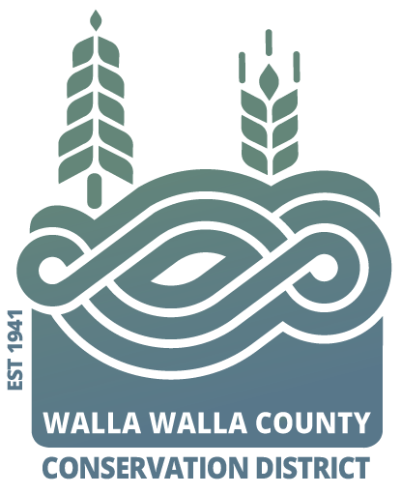
AGENDA
for the Walla Walla County Conservation District
Board of Supervisors Meeting
Monday March 11, 2024 at 5 p.m.
via Zoom & USDA Service Center conference room,
325 North 13th Avenue, Walla Walla WA

Call to Order..................................................................................Chair Kent
Welcome Visitors!
Request for Public Comments:
Minutes of February Board Meeting*
Financial Report

NEW BUSINESS
- Partner updates (NRCS, WSU Extension, WDFW, WACD, and/or SCC) …Hadley
- Living with Beaver and WA relocation efforts & discussion from guest Stephan Bennett
- Review and request to approve new projects
  - VSP riparian Walla Walla River
  - Irrigation Efficiency Pivot (2)
  - Drought
- Summary of NRCS Snake River Local Working Group
PROGRAM UPDATES
- Hadley: District Operations

JOINT AGENCY MEETINGS

Annie: ¹The Nature Conservancy, ²WW County Hazard Mitigation Plan, ³Drought Preparedness Plan creation
Joanna: Snake River Salmon Recovery board

Adjourn……………………………………………………………….. Chair Kent

