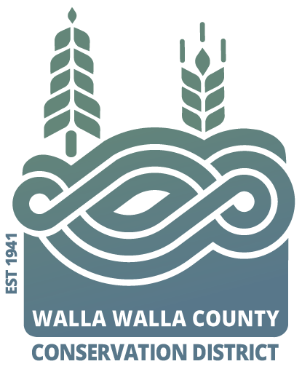AGENDA

for the Walla Walla County Conservation District

Board of Supervisors Meeting

Monday May 13, 2024 at 4 p.m.

via Zoom & USDA Service Center conference room,

325 North 13th Avenue, Walla Walla WA

**Call to Order..................................................................................Chair Kent**

Welcome Visitors! Guest Tom and Ryan from WACD

Request for Public Comments:

**Minutes of April Board Meeting\***

**Financial Report\***

NEW BUSINESS

1. Partner updates (NRCS, WSU Ext., WDFW, WACD, WSDA and/or SCC) Hadley
2. Discussion of WWCCD Internal Audit……………………………….. Freer
   1. *Request to adopt internal audit recommendations
3. *Review and approve Annual Financial Report for Calendar year 2023…Freer
4. Discussion of Coppei Forest thinning and shift to WW Fire Dept. #4 for county thinning with DOC crew…………………………………………………Byerley
5. *Request to approve (reapprove) VSP lower Waitsburg Rd riparian……Traynor
6. *Application for irrigation design update………………………………..Byerley
7. *Request to surplus aging survey equipment……………………………Hadley
   1. Review of inventory

PROGRAM UPDATES

1. Byerley: Irrigation Efficiency Grant Program & Water, Summer Plans
2. Hadley: CD operations

JOINT AGENCY MEETINGS see District Operation Report for summaries

Annie: 1The Nature Conservancy, 2WW Co Water Conservancy Board, 3WW Co Hazard Mitigation Planning, 4Walla Walla Basin Advisory Committee (BAC)

Joanna: 1Snake River Salmon Recovery board, 2Tri-State Steelheaders

Renee: Blue Mountain Land Trust: Conservation committee

Misc. Discussion & Public Comments:

**Adjourn……………………………………………………………….. Chair Kent**