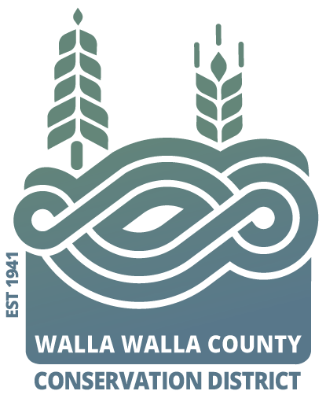AGENDA

for the Walla Walla County Conservation District

Board of Supervisors Meeting

Monday September 9, 2024 at 5 p.m.

via Zoom & USDA Service Center conference room,

325 North 13th Avenue, Walla Walla WA

**Call to Order..................................................................................Chair Kent**

Welcome Visitors!

Request for Public Comments:

**Minutes of June Board Meeting\***

**Review of Financial Report and approval of paying bills\***

NEW BUSINESS

1. Partner updates (NRCS, WSU Ext, WDFW, WACD, and/or SCC) …Hadley
2. Roundtable/Discussion of summer activities………………….
3. Review and approve grants received…………………………………Hadley
   1. Irrigation Efficiency 4th Pivot for 2024.
   2. Windrow/Riparian on Yellowhawk (SCC_SFF)
4. Review and approval of grants applied for…………………………..Hadley
   1. WaterSMART Cooperative Watershed Planning
   2. Ecology 319 Non-Point
      1. Touchet combined RM 35 and design for RM 33.
      2. Lower Mill Creek construction
5. Discussion of FSA mandatory requirement of signing CRP contracts… Hadley
6. October and November board meetings fall on holidays. Keep or move?
7. Annual reviews (MOU list, inventory, or surplus) as time allows…..Hadley

PROGRAM UPDATES

1. Summer activities showcase Coppei 7, Mill Creek FbD, Coppei Bridge
2. Hadley: District Operations

JOINT AGENCY MEETINGS see District Operations Report

Reserved if needed Executive session for 60 minutes to review the performance of public employees (4 different topics) per RCW 42.30.110 (1)(h) or (1)(i)

**Adjourn……………………………………………………………….. Chair Kent**