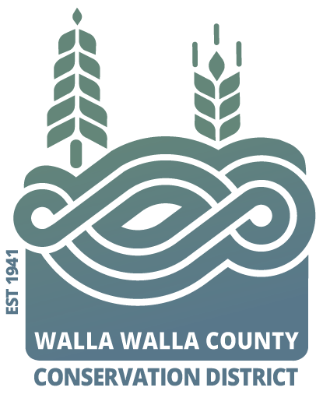AGENDA

for the Walla Walla County Conservation District

Board of Supervisors Meeting

Monday May 12, 2025 at 5 p.m.

Walla Walla USDA Service Center conference room,

325 North 13th Avenue, Walla Walla WA

**Call to Order..................................................................................Chair Schulke**

Welcome Visitors!

Request for Public Comments:

**Minutes of April Board Meeting\***

**Review Financial Report and approve paying the bills\***

NEW BUSINESS

1. Partner updates (NRCS, WSU Ext., WDFW, WACD, and/or SCC) …Hadley
2. *Request to review/edit/ and approve the FY26 annual-plan-of-work…..Hadley
3. *Request to approve grant application as presented
   1. Ecology FY27Water Quality
      1. Touchet River at RM 33 instream restoration (construction)
      2. Lower Mill Creek instream restoration (construction)
      3. Upland soil health and erosion prevention (details TBD)
   2. State Conservation Commission Request
      1. Riparian maintenance (details TBD-Joanna and Grace)
      2. Cover crop seed for outreach (TBD brainstorming ideas)
4. *Request to approve benefit for employees (1 hat plus $50 of apparel of employees choosing)

PROGRAM UPDATES

1. Byerley: Water topics including Irrigation Efficiency, Drought Preparedness Plan and Water forums
2. Hadley: District Operations

**Adjourn……………………………………………………………….. Chair Schulke**

[**Congratulations**](https://agforestry.org/graduation/)

**&**

**Service Presentation**